PRACTICAL EXAMINATION

COS 102 - INTRODUCTION TO PROBLEM SOLVING

TEAM 21 -

ETIM Judith CS-S1

OMORUYI Samara CS-S1

KUSORO Victor CS-S2

TALENT-AJIEH Precious CS-S2

FEMI-SIPE Oluwatamilore SEN

SALIMANU Fawaz SEN

TASK: Pan-Atlantic University has observed that many of its Computer Science students struggle with managing multiple academic and extracurricular responsibilities effectively. From managing assignment deadlines and project milestones to preparing for quizzes and

personal commitments, students often find it challenging to prioritize tasks and allocate time efficiently.

To address this issue, the Department of Computer Science proposed the development of a Smart Task Scheduler to help students track and manage their daily responsibilities more effectively.

Our Team, consisting of Etim Judith, Omoruyi Samara, Kusoro Victor, Talent-Ajieh Precious, Femi-Sipe Oluwatamilore, Salimanu Fawaz from various courses Pan-Atlantic University, was assigned this task and expected to create a solution using python.

To create a solution following the Software Development Lifecycle steps (Planning, Analysis, Design, Development, Testing, Deployment, and Maintenance), roles were assigned to each group member, after assigning roles, meetings were held and discussions were had to decide on design, algorithm and implementation.

Team members roles:  
Fawaz Salimanu - Planning, Analysis and Testing

Omoruyi Samara & Femi-Sipe Oluwatamilore - Design and GUI development

Etim Judith, Kusoro Victor & Talent-Ajieh Precious - Backend and Development

All team mebers helped in debugging and played some role is developing the code.

The developed solution was required to have the following features :

1. Users should be able to add a new task with:

a. Task title

b. Optional Description

c. Priority Level (e.g., 1 = High, 2 = Medium, 3 = Low)

d. Deadline (Date and Time)

e. Estimated Duration (in minutes or hours)

2. The system must allow users to edit and delete existing tasks.

3. The system should be able to display a list of all tasks with sorting based on:

a. Priority level

b. Urgency (how close the task is to its deadline)

4. The system should display visual cues for overdue and urgent tasks.

5. The system must be easy to use. Ensure all buttons are clearly labeled and userfriendly.

6. The system should validate user input properly.

The solution was developed using Object-Oriented Programming and Pythons Tkinter GUI toolkit and psycopg2 to connect to postgres.

The main page for the program was designed to be easy to use and have all items accessible at once, although in the final iteration of the program, some changes were made.

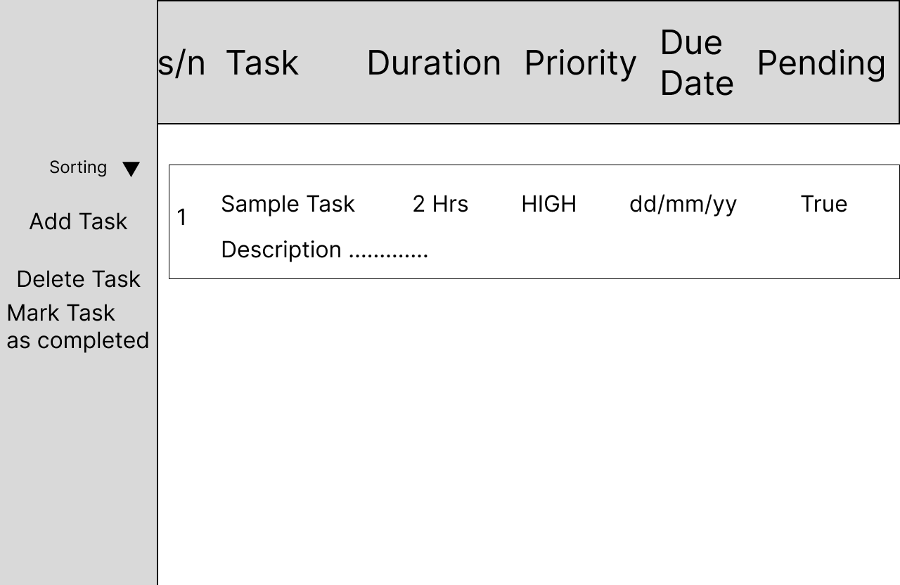

(To run the program you must have a database 'task_manager_db' and must fill in your appropriate postgres credentials into the ‘db_operations.py’, then run the ‘main.py’ file)

On running the program the user is prompted to login, then is greeted with the main page, from the main page, the user can either change the sorting option, add, edit or delete a task.

The program periodically checks to see if any tasks are overdue or due soon, and if any are, it provides visual cues.

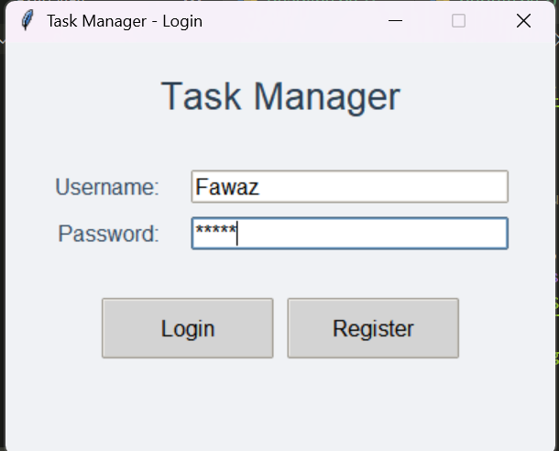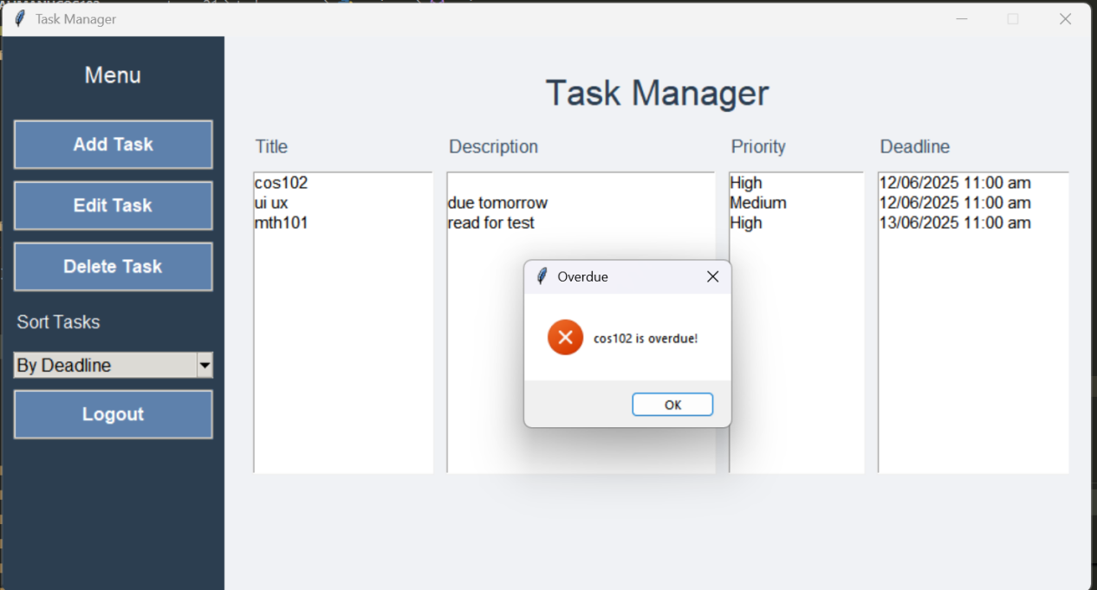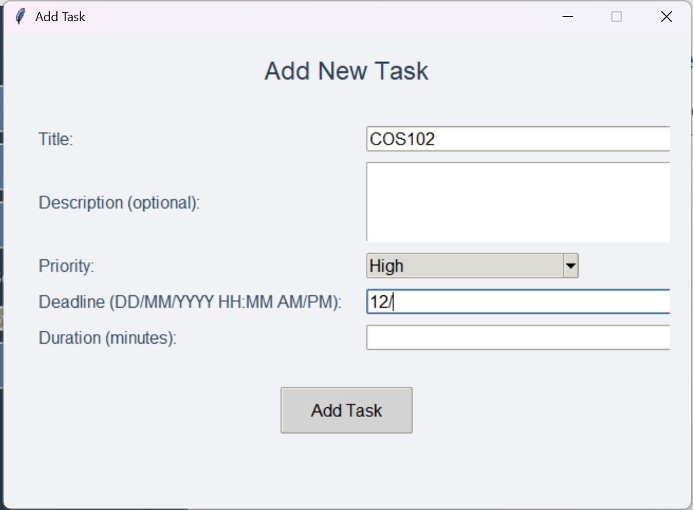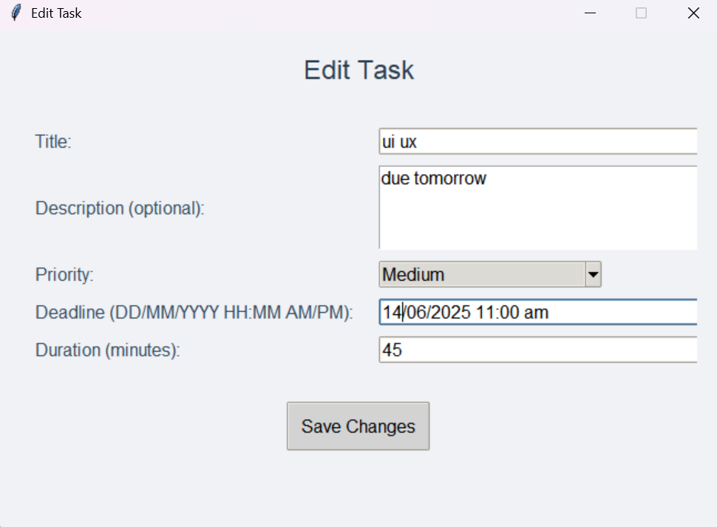

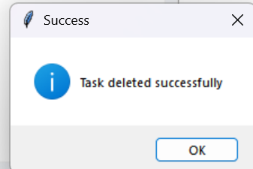

Using a simple and clean design of the program makes it easy to use and provides quick access. Our team was able to successfully implement an effective solution to the assigned task within the given time limit by using Software Development Lifecycle steps utilizing pythons OOP nature and modules such as psycopg2, datetime, tkinter and others.